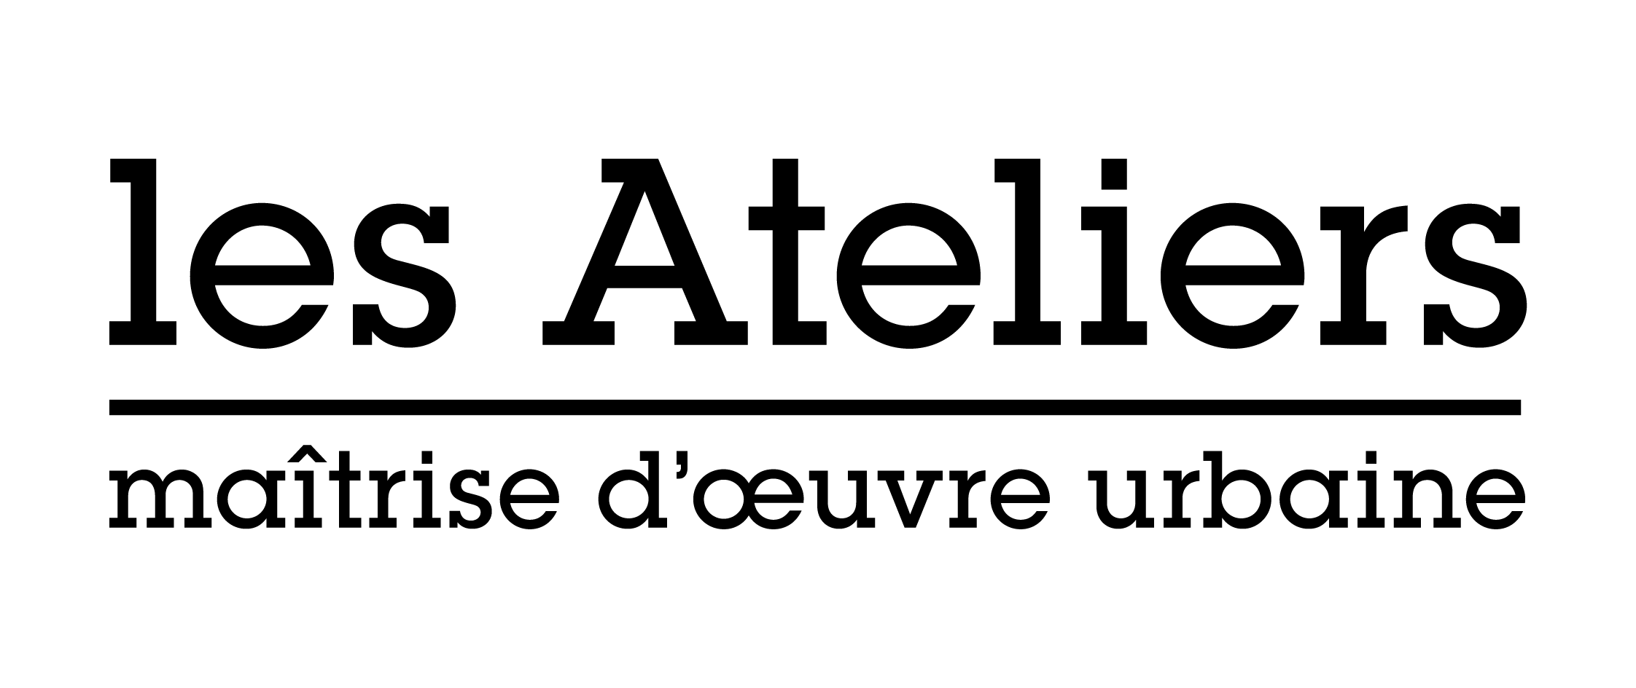Application form

**International Workshop on Urban and Territorial Creativity**

“The River Seine as a Great Garden: The Sources”

|  |
| --- |
| *Photo (optional)* |

Family name:

First name:

Date of birth:

Nationality:

Postal address:

E-mail:

Mobile phone:

Somebody to contact in case of problem:

Phone of this person:

Degrees:

Current situation:   
  
How did you hear about Les Ateliers?

|  |  |
| --- | --- |
| Former participation |  |
| Friend/colleague |  |
| University/professors |  |
| Internet |  |
| Other (please specify) |  |